**MEMORY LOCATION AND ADDRESS**

***1.INTRODUCTION:***

Hello guys! At the end of this blog you can understand what is data and how it is stored in the computer and how do you access the data in the storage using address. This article will cover memory location and address from a basic term to the clear understanding. Let’s get start the with basic.

***2.BASIC CONCEPTS:***

Before enter the main topic (memory location and address), we must understand the basic concepts what is data? And what is memory? In computer point of view all the contents are in the form of 0s and 1s only known as binary. That is all other types such as characters, numbers and special character are converted into 0s and 1s. There is a standard to convert the give text or number into binary is **ASCII (**American standard code for information interchange) which is commonly used in world wide.

***2.1 WHAT IS DATA?***

Data is fundamental for all the operation of a computer system. All the characters, numbers and instructions all are data. Which contain some information. To store or access these data we have to convert it into the binary format known as bit, byte. To convert these data into bit is done by using the character encoding standard known as (ASCII).

***2.1.1. BIT***

A bit is a single and smallest unit of data which is either 0 or 1. Every single characters and text will be converted into the combination of bits or the collection of the bits.

***2.1.2. BYTE and WORD***

A collection of 8 bits is known as byte. It is fixed unit not change by anything. The number of bits that the processor can process at a time is known as word size.

For example, I have an 16 bit processor means that the processor can process 16 bit at a time.

***2.3. ASCII***

American standard code for information interchange is a standard used to encode the characters and special characters. It assigns numeric codes to all characters, special character, hexadecimal, decimal. The below will show the numeric codes.

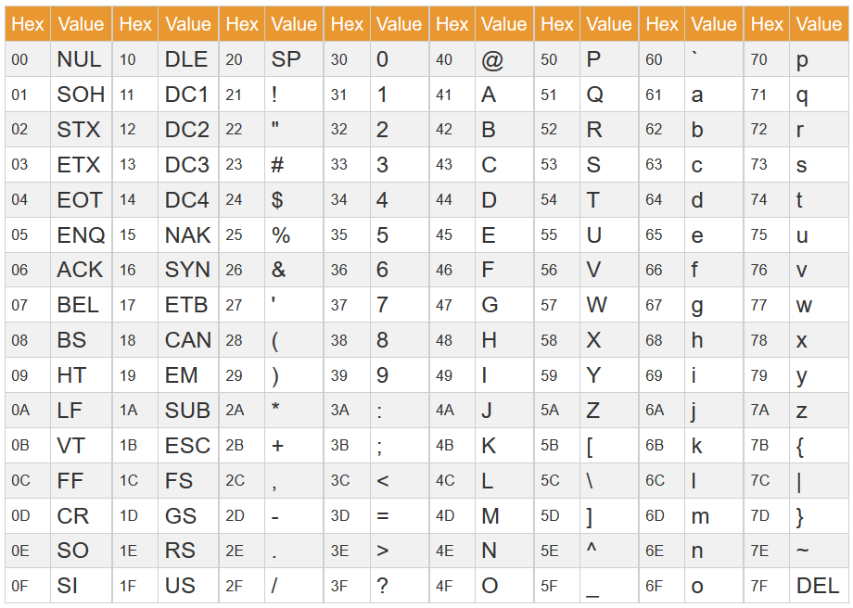

***2.2. WHAT IS MEMORY?***

All the numbers, characters as well as instructions are stored in the memory of a computer. Did you think about what is memory? And how the data are stored in the memory? Because computer only deals with 0s and 1s. The answer for this question will be cleared in this blog.

The memory consists of more than a million of storage cells, each storage cell is eligible to store one bit of data. Storage cells are made up of electronic circuit it may be on or off (1 or 0) state. By using the collection of these millions of the storage cell we can store the data as much as possible.

***2.2.1. WHY MEMORY ADDRESS IS NEEDED?***

From this a new doubt will arise, storage cells stores the data but there are several millions of storage cells are available how do we know which cell consists which data? and how to retrieve it and access it? This situation is similar to search a house without knowing address. The solution of this problem is giving address to the cells.

***2.2.2. BYTE ADDRESSABILITY***

Let us consider we give a unique address to individual bits. But it is very hard process to complete and manage. It is complex tasks which rarely used. To reduce that complexity we group the number of bits and generate the address of each of the group separately. Another method is word which is the collection of n bits known as word and n is the word length. By using this instead of assign a unique address to the bit we give a unique address to the individual byte or word.

If you have k bit processor then you will generate the 2^k unique addresses. This is because each bit can have two possibilities. The number of unique address decides the maximum amount of memory that the processor can access directly. K bit processor can process k number of bit at a time. So, the 2^k means the maximum amount of memory a processor can address directly. If the amount of words exceeds more than 2^k then the processor uses different methods like paging, physical memory and virtual memory.

There are two types of assigning the byte address there are Big-endian assignment and Little-endian assignment. In big endian assignment the left most byte has first preference and the address were given as per the below diagram and the little endian is the opposite of the big endian the right most byte has first preference and the address were given as per the below diagram.

For a 32bit processor, the word length is 32 bit and it can store 4 byte or a single word. For word the address is given as 0 4 8 … because the first word has 4 bytes.

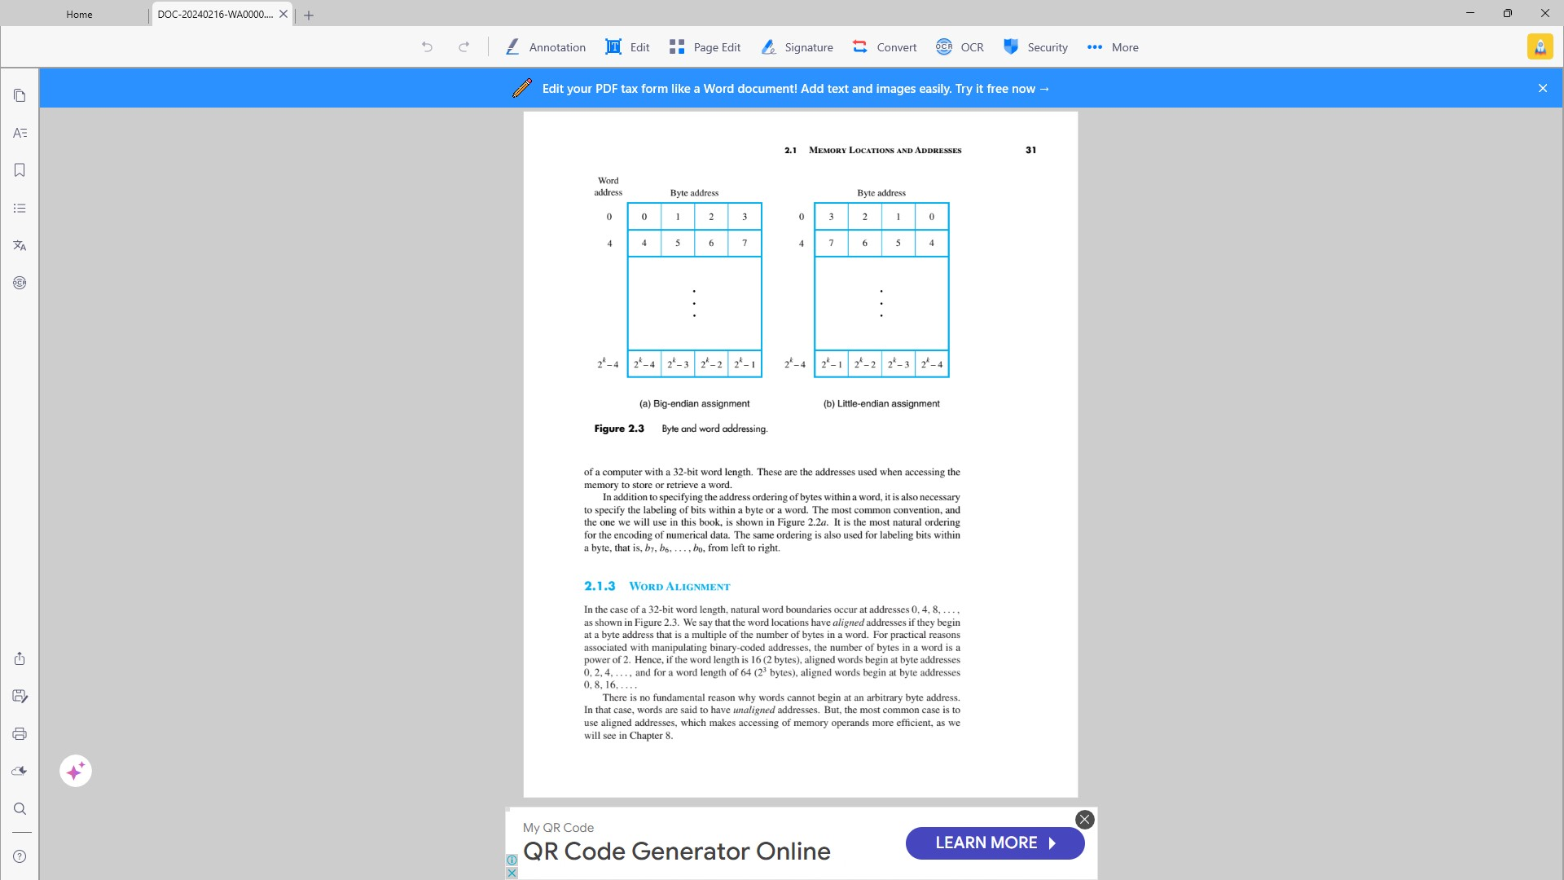

***PHYSICAL ADDRESS AND LOGICAL ADDRESS***

Physical address was generated by the hardware, specifically by the memory management unit. Which is used to access the memory directly. But programs use a logical address to access. But it not actually access the memory by logical address the memory management unit (MMU) will receive the logical address and convert it into the physical address. And by using this address we can access memory. MMU uses different methods like paging, segmation and so on.

Virtual address is generated by the program itself at compile time or load time. Programs use logical address to access memory locations. There are different process like binding used to convert the virtual address into the physical address.